Background:
A project code is required in order for resources to be able to track their time on the IRI time-track system on a bi-weekly basis.

Normally a project code can be obtained once a project is approved at PQC.

Sometimes a project may require POC work prior to approval. This work will utilize resources who need to track their time. Therefore, it is possible to obtain a project code prior to project approval as long as approval is received from the MK PMO.

Steps for obtaining the project code:
- Fill out the XL request form LDCodeReqForm.xls:

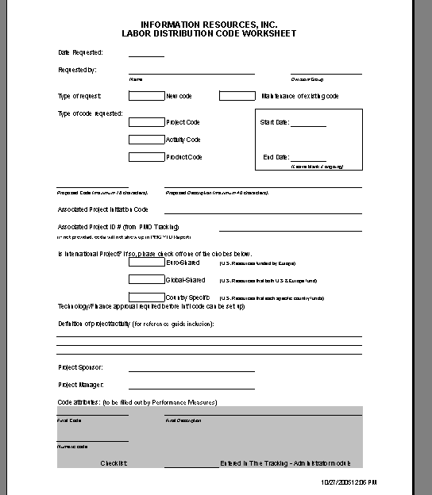

- Call Jonathan Doucette (x. 2446) and give him the background for the request and a “heads up” that you are emailing it out.

- Until January 2006 email the completed request to:
  - Nancy Dunn – nancy.dunn@infores.com
  - Copy Jonathan Doucette – jonathan.doucette@infores.com
  - Copy Martin Wills – martin.wills@infores.com

- After January 2006 Reyna Mass will return from maternity leave and you should email the completed request to:
  - Reyna Mass – reyna.mass@infores.com
  - Copy Jonathan Doucette – jonathan.doucette@infores.com
  - Copy Martin Wills – martin.wills@infores.com

